ZADAR BASKETBALL SCHOOL
ADIDAS INTERNATIONAL SUMMER
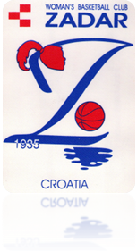
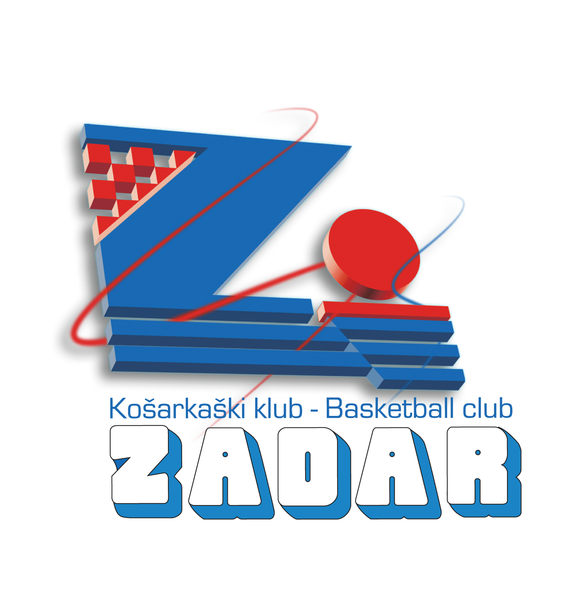

C A M P 2 0 1 1
Basketball school ‘Zadar’ is one of the best organized basketball schools in Croatia. All trainings are held in halls of the Sports centre Visnjik – BASKETBALL HALL ‘KRESIMIR COSIC’. It has got a large number of participants, girls and boys. The school works according to the program verified by the Ministry of Education and Sports (author Umberto Piasevoli).
Coaches for boys: Umberto Piasevoli, Alen Zrilic, Boris Valcic
Condition coach and mini basket: Martina Šango
Coaches for girls: Marija Mazija, Rajko Vidaković, Luka Hoti

:: WHERE will ZADAR BASKETBALL SCHOOL INTERNATIONAL SUMMER CAMP 2011 be held?

:: BASKETBALL HALL “KREŠIMIR ĆOSIĆ :: CITY of ZADAR
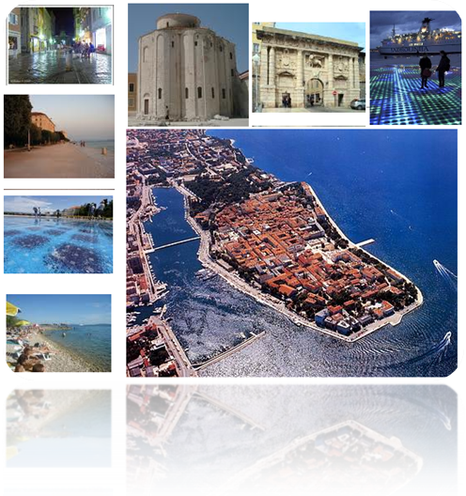
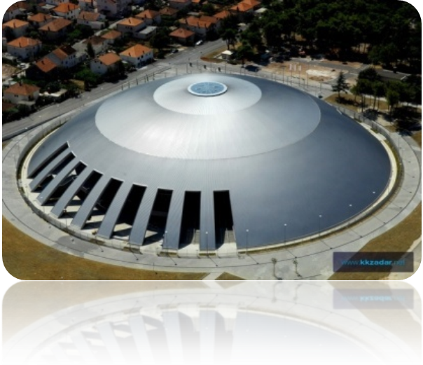

The Sports Centre Visnjik is located on the same north-eastern part of the town of Zadar. From the Peninsula there are 20 minutes of walk, and almost equally from all other parts of the town. The Centre Visnjik can be reached by the motorway from Zagreb for 2.5 hours and by the Adriatic road from Rijeka for approximately 4 hours. The town of Zadar can be reached by ferry from all main Croatian ports, from all the islands, and from neighboring Italy. The airport connects the town of Zadar to all important towns in Croatia, as well as to all major European capitals.
The hall was begun in the 2004 and it was completed in October 2008. Since the 1st October 2008 the Hall was named Kresimir Cosic.
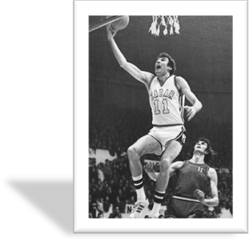
Kresimir Cosic was a player ahead of his time, the first who was able to arrange a game. He had an extraordinary sense of space and arrangement of players on the field, knowing to add the ball at the right time. He could do things that no center before him could..
- Member of the HALL OF FAME
- The first European selected in NBA Draft

Along the hall there is a complex of outdoor courts, basketball playground, athletic track, football playground, handball and indoor soccer playground, volleyball playground and a training ground for exercising.

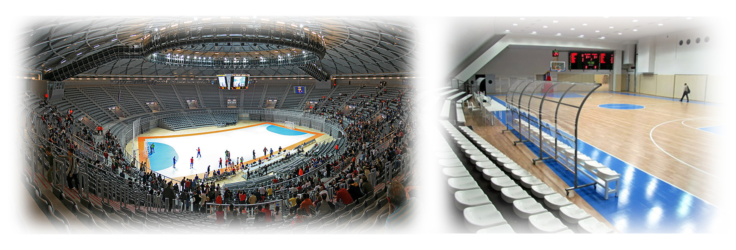

:: WHEN will ZADAR BASKETBALL SCHOOL INTERNATIONAL SUMMER CAMP 2011 be held?
THREE shifts in the period from 18. 06. 2011. – 09. 07. 2011.

- FIRST SHIFT: 18. 06. 2011. – 25. 06. 2011.
- SECOND SHIFT: 25. 06. 2011. – 02. 07. 2011.
- THIRD SHIFT: 02. 07. 2011. – 09. 07. 2011.

:: AGE?
From birth year 1995. to 2002.

The program includes a seven-day camp stay in Zadar with accommodation in a cottage "Campiente - mobile chalets" (triple or quadruple) which are placed in the shade of pine trees Borik camp on the beach. Meals on full board are organized in a nearby hotel "Donat", and the supply of food is a buffet self-service, plus there is a swimming pool.

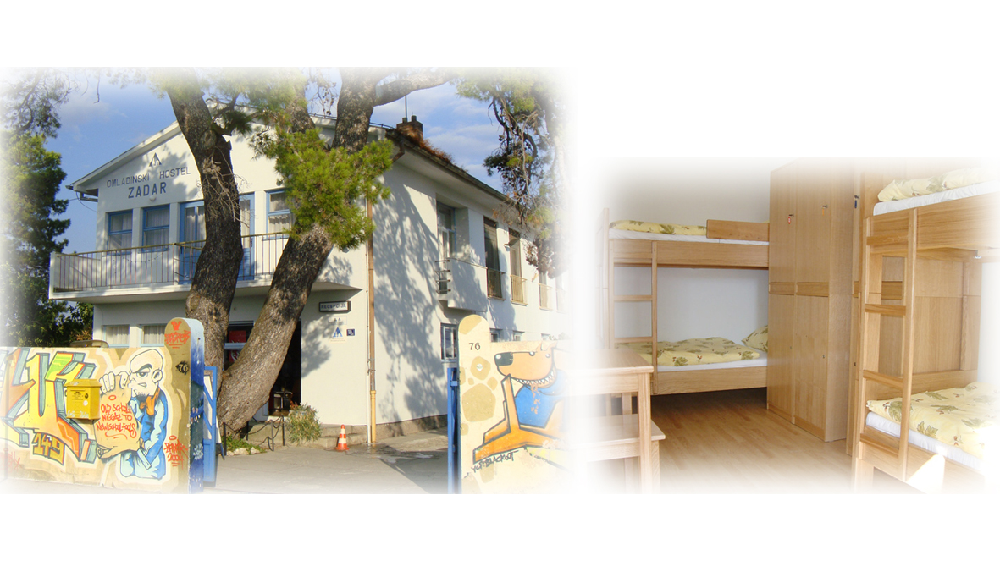
Mobile chalets includes: full kitchen (refrigerator, microwave, coffee machine ...). Shower and toilet, living room with TV (satellite), CD player, terrace with table and chairs.

Note: third shift will be located
in Youth Hostel Zadar
In vicinity of the hostel are two
beaches, and in front of the hostel
lays colorful marina Borik. In the
hostel there is also a bar and a
restaurant as well as a sports
playground, the conference room
and other facilities.

:: PRICE of the CAMP?

The price of the camp is 300 EUR and it includes:

      - Transportation from airport to accommodation
- Accommodation and meals (3 meals per day)
- Transport from accommodation to the hall
- Trainings will be held twice a day, in the morning and in the evening at the basketball arena, with the possibility of using the outdoor playgrounds.
- Each participant in the camp receives a gift (the occasional sports equipment for training, and special awards for placing in competitions)
- Medical care
- Special guests (famous players and coaches)

:: PAYMENT?

- Participants could make a payment for BASKETBALL SCHOOL "Zadar" at No. 2402006-1100504821
- There is possibility of annuity payment (3) or cash (when arriving to camp)

:: INFO

Fax: +385 23 230 750
Tel: +385 91 720 9453 (Umberto Piasevoli) Basketball camp manager
Tel: +385 91 380 3381 (Alen Zdrilić) / Basketball camp assistent manager
Executive director of Basketball camp: Giuseppe Pino Giergia
President of Basketball school “Zadar”: Tonći Jerak
e-mail: skola.kosarke.zadar@zd.t-com.hr
www.kkzadar.net/skola-kosarke/
ZADAR BASKETBALL SCHOOL INTERNATIONAL SUMER CAMP 2011

NAME :

SURNAME :

DATE OF BIRTH :

TELEPHONE NUMBER / E-MAIL ADRESS :

BASKETBALL CLUB:

SWIMMER : YES / NO

HEIGHT:

JERSEY SIZE : XS / S / M / L / XL / XXL

BASKETBALL CAMP SHIFTS :

- 18. 06. 2011. – 25. 06. 2011.
- 25. 06. 2011. – 02. 07. 2011.
- 02. 07. 2011. – 09. 07. 2011.

